**Project Proposal**

**For the**

**Fly Creek - Smith Property**

**Riparian Fencing Project**

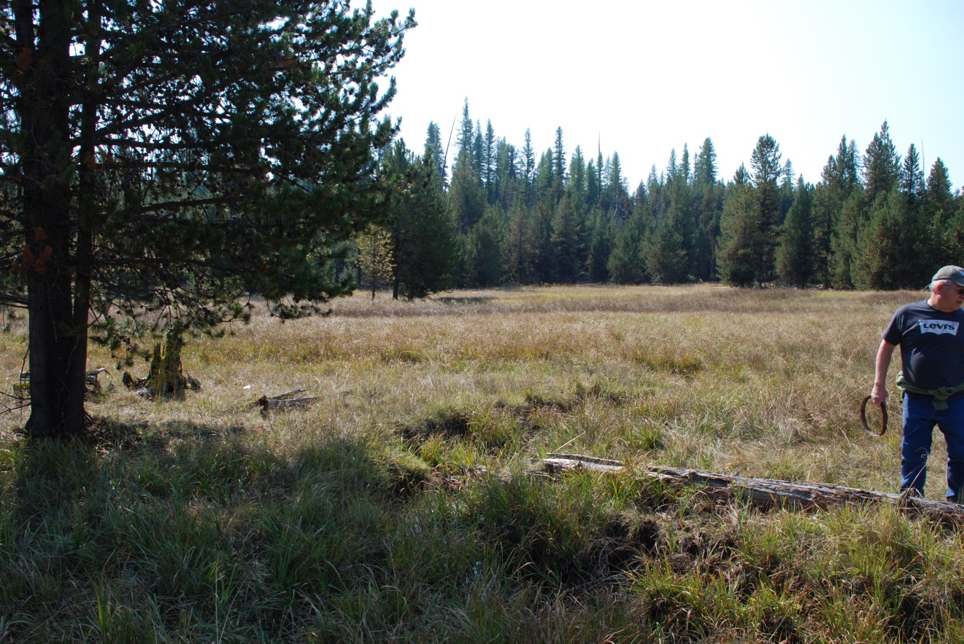

**Submitted to the Grande Ronde Model Watershed for Consideration by**

**Colleen Fagan and Matt Saladin**

**Oregon Department of Fish and Wildlife**

**09/15/2014**

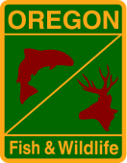 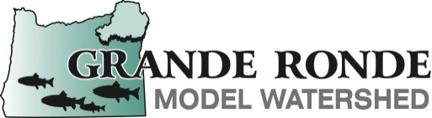 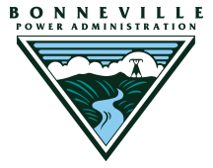

**Project Name:**

Fly Creek-Smith Property Riparian Fencing Project

**Applicant:**

Oregon Department of Fish and Wildlife, Grande Ronde Basin Fish Habitat Enhancement Project

**Participating Landowner(s) and Project Partners:**

Fred Smith (Landowner)

Oregon Department of Fish and Wildlife

Bonneville Power Administration

Grande Ronde Model Watershed

**Project Contacts:**

***Administrative***

Colleen Fagan, ODFW

107 20th Street

La Grande, OR 97850

541-962-1835

[Colleen.e.fagan@state.or.us](mailto:Colleen.e.fagan@state.or.us)

***Technical***

Matt Saladin

107 20th Street

La Grande, OR 97850

541-962-1833

[Matt.b.saladin@state.or.us](mailto:Matt.b.saladin@state.or.us)

**Project Location:**

The Fly Creek-Smith Property riparian fencing project (Figures 1 and 2) is located at approximately River Mile (RM) 13 of Fly Creek, a tributary to the Grande Ronde River, in Umatilla County, Oregon, and described as follows:

Township 5S, Range 34E, Section 16

NE1/4 NE1/4

NE1/4 NW1/4, N1/2NE1/4

N1/2NW1/4 Section 16

**Project Objectives:**

1. To protect approximately 15 acres of stream and wetland habitat from livestock impacts to address limiting factors for Endangered Species Act listed spring Chinook salmon, summer steelhead, and bull trout in Fly Creek and the Upper Grande Ronde watershed.
2. To improve existing fence line and associated structures to provide continued protection from livestock and to maintain benefits already realized to salmon and steelhead habitat.

Fly Creek is a 303(d) listed stream segment. Parameters of concern are temperature, sedimentation, and habitat modification.

The Grande Ronde Subbasin Plan (GRSP) identifies the Upper Grande Ronde watershed as an area that could largely benefit from habitat restoration. Fly Creek is ranked the third highest priority geographic area for restoration benefit for spring Chinook salmon and the eighth highest ranked area for restoration benefit to summer steelhead in the Upper Grande Ronde. Limiting factors identified for summer steelhead and spring Chinook salmon in Fly Creek include high summer water temperatures, degraded riparian conditions, excess fine sediment, and lack of habitat diversity. Sediment is identified as the key limiting factor for spring Chinook in Fly Creek with restoration priorities identified as those reducing sediment delivery and improving riparian condition to decrease temperatures and increase wood inputs. When implemented, the proposed project will contribute to improving limiting factors identified in the GRSP for Fly Creek and the Upper Grande Ronde basin for spring Chinook salmon and summer steelhead by:

* Decreasing sediment input to Fly Creek;
* Increasing bank stability along Fly Creek;
* Increasing riparian vegetation along Fly Creek;
* Increasing stream shading along Fly Creek;
* Increasing habitat diversity;
* Increasing woody debris in stream;
* Increasing fish cover; and
* Protecting wetland habitat

**Project Description:**

**Introduction**

In 1986, ODFW surveyed a four mile section of Fly Creek from USFS Road 5155 upstream. Twenty-four summer steelhead redds were counted above Little Fly Creek. Stream conditions below Little Fly Creek precluded identification of redds. Spawning surveyors observed that there was much unused spawning gravel, bank degradation was a combination of erosion and cattle use, and any establishment of bank vegetation over current levels would greatly enhance stream shade and cover and also provide habitat for a large number of nongame wildlife species.

In 1987, ODFW fenced 14.8 riparian acres along 1.2 stream miles of Fly Creek. The original lease was signed April 1, 1987 with an expiration of May 31, 2003. An addendum extending the lease until March 31, 2013 was signed March 12, 2003. ODFW personnel met with Fred Smith (landowner) on July 08, 2014 to discuss a new easement for the property. ODFW and the landowner agreed to a new 25 year easement. In addition, the landowner has agreed to ODFW fencing an additional 0.3 stream miles (15 acres), decreasing the size of an existing water gap from 100 feet to 50 feet, and modifying 1,300 feet of the existing fence line.

The new fence line was staked out with the landowner on September 08, 2014. ODFW also surveyed the existing fence line and identified structures needing replacement.

**Existing Condition**

Impacts of elevated temperature, sediment and habitat modification are widespread throughout the Upper Grande Ronde Watershed. Loss of floodplains and wetlands has eliminated rearing areas for juveniles. Excessive amounts of fine sediment in various portions of the subbasin negatively affect incubation success, juvenile survival, invertebrate production, and habitat availability.

***New Fence***

Within in the area proposed for fencing, livestock grazing occurs annually. Livestock grazing contributes to streambank erosion and increased sediment input to Fly Creek. Livestock also browse adjacent riparian vegetation decreasing density, condition and species composition and modifying stream habitat quantity and quality.

Suitable spawning gravel is present within the area proposed for fencing, but summer steelhead spawning has not been documented on the property (Figure 3).

Several wetland areas and a large meadow will be included in the fenced area (Figure 4).

***Existing Fence***

The existing fencing project includes 1.7 miles of fence, seven stream crossing fences, and three water gaps. The high tensile riparian fence at Fly Creek was installed in 1987. Nearly three decades of weather and stress has weakened and rotted many wood structures supporting the fence, particularly H-brace cross members (Figure 5). Footer and rock tie down wires have also rusted out. This leaves the structures prone to being pulled over or out of the ground by the high tension of the tensile wires. In order for the fence to function properly, multiple structures need to be replaced.

The lower water gap near the US Forest Service boundary is 100 feet wide. Hoof shear and cut banks in this area have increased fine sediment input to Fly Creek. The landowner needs this water gap for livestock and to access firewood east of Fly Creek. The landowner, however, has agreed to ODFW narrowing this gap from 100 feet to 50 feet, which will still provide livestock and landowner access to both sides of the stream.

Along 1,300 feet of the existing fence line, the stream bank has encroached on the existing fence and structures (Figure 5). ODFW and the landowner support realigning the current fence line out approximately 20 feet.

Eleven photopoints have been established to monitor changes in habitat and vegetation associated with the existing fencing project. Notable changes that have occurred are an increase in riparian vegetation (size, density, and composition), an increase in habitat diversity (LWD and complexity), an increase in channel stability, and an increase in bank stability (Figures 6-11). Several pools and areas of spawning gravel are present in Fly Creek within the existing fence.

**Specific Actions**

***Task 1. Clear a 10 foot wide corridor along the new fence line.***

In certain locations of the proposed fence line, substantial vegetation clearing is needed (Figure 12). A 10 foot wide corridor shall be cleared along the fence line. At least 6 feet of the cleared corridor shall be on the outside of the fence (the side away from the stream). The corridor shall be cleared of all trees, brush, downed timber, stumps and any overhanging branches within 6 feet of the ground. This will allow construction of the fence and travel along the fence with an ATV or horse. All clearing shall be done using manual or powered hand tools.

No vegetation within 20 feet of the stream shall be damaged or removed unless directed by ODFW.

Dead standing trees that could damage the fence if they fall shall be felled by the contractor and left on the stream side of the fence prior to the new fence being constructed. They shall be placed such that they are not likely to be washed into the stream channel. ODFW shall determine which trees shall be felled.

Cleared brush is to be left on the stream side of the fence and out of the high water zone. ODFW will indicate to the contractor if and how brush piles are to be made.

***Task 2. Construct a six strand high tensile fence along 0.3 miles of Fly Creek, to ODFW specifications and standards.***

A six strand high tensile fence and related structures shall be constructed by a contractor to ODFW’s specifications. The fence shall be constructed along 0.3 miles, protecting 15 acres of riparian, wetland, and upland habitat. The fence will be constructed outside the flood prone area.

***Task 3. Decrease width of existing water gap crossing from 100 feet to 50 feet.***

At the lower water gap near the US Forest Service boundary, the existing fence line will be extended 50 feet to protect additional stream and bank habitat from livestock grazing and hoof shear.

***Task 4. Realign 1,300 feet of existing fence line.***

Approximately 1,300 feet of existing fence line will be realigned to widen the exclosure 20 feet.

***Task 5. Place woody material in stream to create fish habitat and cover.***

Woody material from fence line clearing will be placed in the stream in areas identified by ODFW to increase cover and habitat complexity, and to protect banks from erosion.

***Task 6. Restore all ground disturbed as a result of fence construction to as near original condition as possible.***

The contractor shall be responsible for restoring disturbed ground.

**Benefits**

This work will add 0.53 miles (15 acres) to 1.7 miles of fence (14.8 acres) installed on this private property in 1987. In addition, the lower water gap near the USFS property line will be decreased in size to decrease erosion and hoof shear. Realignment of 1,300 feet existing fence line will occur, widening exclusion area 20 feet. Multiple wetland areas will be protected within fencing.

The priority in basin limiting factors are low flows, sediment reduction, channel condition, and, riparian function. The GRSP recommends 1) reducing upland erosion and fine sediment inputs to aquatic habitats; 2) restoring channel condition to appropriate habitat characteristics and channel form; and 3) restoring riparian function. This fencing project addresses all of these limiting factors and provides multiple benefits, including:

* Improved density, condition and species composition of riparian vegetation through grazing management and planting and seeding if necessary;
* Stabilization of active erosion sites through use of wood and vegetation reestablishment;
* Improved riparian function and water storage by enhancing riparian vegetation;
* Improved habitat complexity and channel condition through installation of wood;
* Increased habitat diversity by improving channel and riparian conditions; and.
* Protection of existing wetlands through grazing exclusion.

**Project Maintenance**

ODFW will maintain all new project fences around the leased riparian habitat area. An annual fence inspection will occur once each spring, prior to the grazing season. Repairs will be made prior to the grazing season. Subsequent fence inspection and maintenance will occur approximately every 10 to 14 days and any livestock within the fenced area removed. Inspection and maintenance of the fences by ODFW will be done contingent on the availability of funds from the Bonneville Power Administration.

**Permits**

A Cultural Resources Section 106 permit will need to be obtained for this project. ODFW will be responsible for ensuring a cultural resource survey and report are completed and that Oregon State Historic Preservation Office Section 106 concurrence has been obtained.

**Monitoring Plan**

ODFW will monitor the contract during vegetation clearing and fence construction and ensure contract specifications are being met.

ODFW will also monitor the fence condition pre, during, and post grazing season to ensure desired results are achieved. ODFW will frequently visit the project area to monitor for livestock presence and/or grazing effects. Any livestock within the exclosure will be removed and necessary repairs made to the fence.

Photopoints will be established to monitor changes in riparian vegetation and project effects. Photographs will be taken prior to fence construction, during fence construction and year 1 and 3 after project completion. After year 3 post completion, photographs will be taken every three to five years for effectiveness monitoring.

Suitable spawning gravels are present in the project reach. ODFW will conduct summer steelhead spawning ground surveys for a minimum of 3 years post project construction to determine if summer steelhead spawning is occurring and to document locations of redds.

**Work Dates**

The new fence line was staked out with the landowner on September 08, 2014. Fence construction and realignment would be initiated and completed in the summer of 2015. ODFW anticipates construction would occur sometime between July and October 2015.

**Project Budget:**

See attached

**Attachments:**

Project Maps

Project Photographs

Project Budget